Notes: If you are installing windows binary distribution, please download and install Microsoft Visual C++ 2013 redistributable https://www.microsoft.com/en-us/download/details.aspx?id=40784

Neural network Add-Ons Neuronica for OpenOffice.org provides three neural networks learning algorithms by back propagation method:

1. Classic Backpropagation
http://en.wikipedia.org/wiki/Backpropagation
2. Resilient Propagation (RProp)
http://de.wikipedia.org/wiki/Resilient_Propagation
3. Scaled Conjugate Gradient (SCG)
http://en.wikipedia.org/wiki/Conjugate_gradient_method

To work with Add-Ons press the menu «Neural / Backpropagation network...» which opens a main dialog: window:
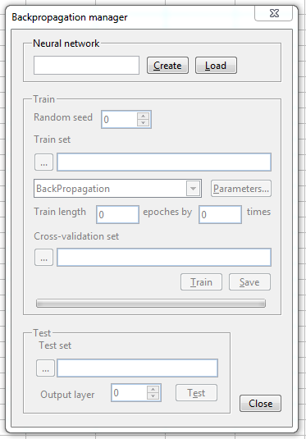
- To create new neural network you need to input the network structure in the input box in format InputLayer.HiddenLayer1....HiddenLayerN.OutputLayer. For simple XOR task the network structure will be like 2.2.1, i.e. input layer with 2 neurons, one hidden layer with 2 neurons and ouput layer with 1 neuron.
- Press the button Create. If network structure is ok the new network will be created and at the right you will see OK. Next we will examine neural network function by the example of its learning to (of) logical operation XOR.
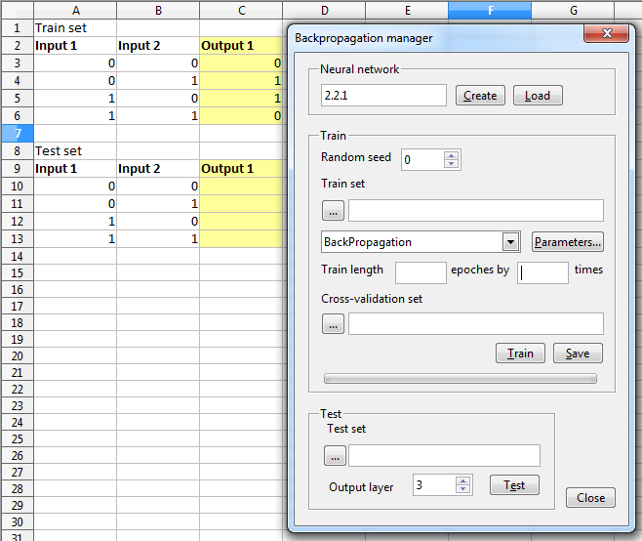
- Set the random seed in the appropriate field.
- Select the train set by pressing the […] button:
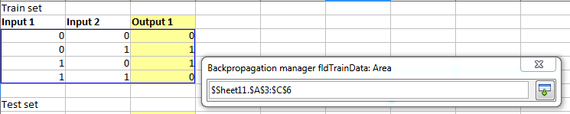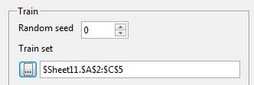
- Select the algorithm and its parameters by pressing appropriate button.
- Set the train length – it need to fill both fields: “epoches” and “times”. The total number of training cycles is epoches * times, and the program will save the train (and cross-validation) error n these times (50 times in this case)
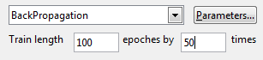
- Select the cross-validation set if it necessary
- Press the Train button.

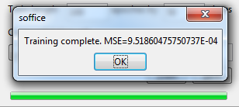
- After the train procedure will be complete you will see the message window with mean square error on train set.
- Next it is possible to test the trained neural network. Select the test set (just input space!):
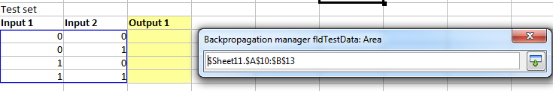P
- Press the Test button – all output columns will be show at the right of the test input data:
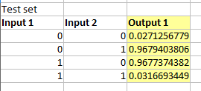
- Also you can select for test procedure not only output layer (3rd in this case), but any hidden layers. Remember, in this case the quantity of output columns will be equal the quantity of neurons in the selected hidden layer.
- Finally, you can save the trained network – press Save button. All data will be saved on the the worksheet.
- In future this already learned neural network can be loaded by Load button.

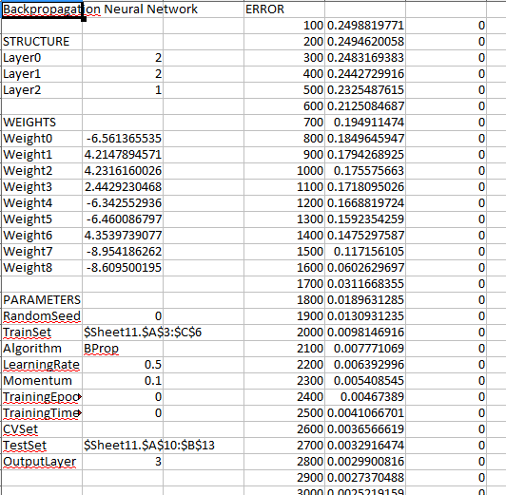
- Finally, after save you can create train error diagram using standard OpenOffice.org tool and ERROR data in the saved sheet. You can select both train and cross-validation error data if cross-validation set was chosen earlier. Otherwise all cross-validation data will be equal 0 (as shown above).
